REGISTRATION FORM  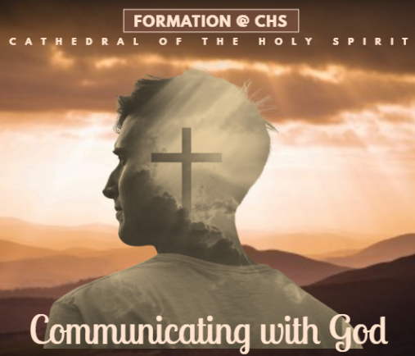  Power in Prayer  Fr Ryan Innas Muthu  May 11, 2019 | Saturday | 9am to 3pm  Dewan Holy Spirit | Cathedral of the Holy Spirit  Closing Date : 6 May 2016 (Monday)  Please submit Registration Form @ Parish Office  Fee : RM 10/= per person  Name : NRIC # :  Parish : Ministry :  Contact : Email :  Fees : Paid / Unpaid Date :  Receipt : | REGISTRATION FORM  Power in Prayer  Fr Ryan Innas Muthu  May 11, 2019 | Saturday | 9am to 3pm  Dewan Holy Spirit | Cathedral of the Holy Spirit  Closing Date : 6 May 2019  Please submit Registration Form @ Parish Office  Fee : RM 10/= per person  Name : NRIC # :  Parish : Ministry :  Contact : Email :  Fees : Paid / Unpaid Date :  Receipt :
Further details contact –  - Parish Office @ 04 658 4909  - Christine @ 012 402 5292 | Further details contact –  - Parish Office @ 04 658 4909  - Christine @ 012 402 5292

